Cairo University Computer Languages for Modeling

Faculty of Computers and Artificial Intelligence Spring 2021

Operations Research and Decision Support Department Lab #1

**Lab Objectives**

* VLOOKUP and HLOOKUP Functions
* Matrices and their Functions
* Logical Functions
* Data and Histograms

**Part 1**

1. Get the name of each student’s department using the department code.

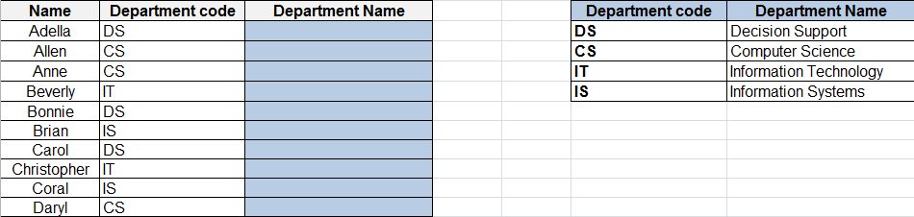

1. VLOOKUP: You can use the VLOOKUP function to search the first column of a range (range: Two or more cells on a sheet. The cells in a range can be adjacent or nonadjacent.) of cells, and then return a value from any cell on the same row of the range
2. HLOOKUP: Searches for a value in the top row of a table or an array of values, and then returns a value in the same column from a row you specify in the table or array.
3. Use HLOOKUP when your comparison values are located in a row across the top of a table of data, and you want to look down a specified number of rows.
4. Use VLOOKUP when your comparison values are located in a column to the left of the data you want to find.
5. The V in VLOOKUP stands for "Vertical" and The H in HLOOKUP stands for "Horizontal"

**Part 2**

1. Open a new sheet and name it “Matrices”, then use the two matrices below to calculate the following:
   1. C = A*B
   2. A+B
   3. D = -5A
   4. Trans (A)
   5. Determinant of C
   6. Inverse of C

|  |  |  |  |  |  |
| --- | --- | --- | --- | --- | --- |
| **A  (matrix 4x5)** |  |  |  |  |  |
| 81 | 52 | 12 | 20 | 31 |  |
| 50 | 10 | 1 | 70 | 21 |  |
| 20 | 9 | 8 | 32 | 65 |  |
| 65 | 75 | 33 | 75 | 3 |  |

|  |  |  |  |
| --- | --- | --- | --- |
| **B  (matrix 5x4)** |  |  |  |
| 42 | 86 | 11 | 83 |
| 25 | 35 | 37 | 34 |
| 27 | 62 | 26 | 61 |
| 16 | 75 | 98 | 68 |
| 46 | 44 | 63 | 67 |

**Part 3**

1. Given the data shown below, solve the following questions:
   1. Construct a function called “Bonus” that calculates for each salesman the amount of his bonus.
      1. When the income is more than or equal the min value **and** less than or equal the max value, it will multiply the bonus percentage by the income.
      2. Otherwise it will show message “No Bonus”.
   2. Compute the average for the income if it is greater than 100000
   3. Count the incomes that are greater than 100000.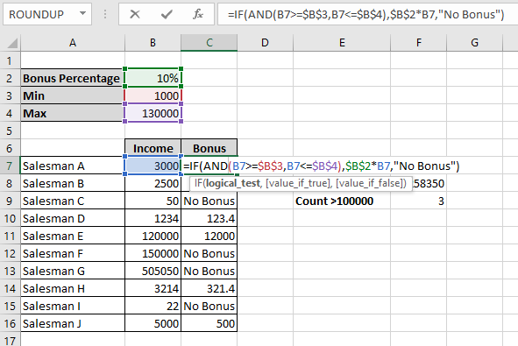

**Part 4**

1. Given the format in the excel sheet named “Part 4”, solve the following questions:
   1. In column A, generate 100 random numbers.
   2. In column B, copy the numbers you generated and past them as values

(Hint: generated random numbers change with every calculation done)

* 1. In column C, use the following equation to vary the numbers from a range of (1 – 100)

Lower Limit + (Upper Limit – Lower Limit) * random number

* 1. Round up the numbers in the cells to two decimal places
  2. Center the contents of the whole sheet.
  3. Generate the frequency table with its histogram for the Data Set column.

(use two different methods)

* 1. Use the data analysis add-in to generate cumulative chart for the “Data Set” column

(Hint: the classes intervals are of width = 20)